# Detailed demo instructions User manual for Best Fit Algorithm:

1. Install java and add it’s address to the system environment variable.
2. Download my submission file.
3. Unzip file and place the file structure as shown below.

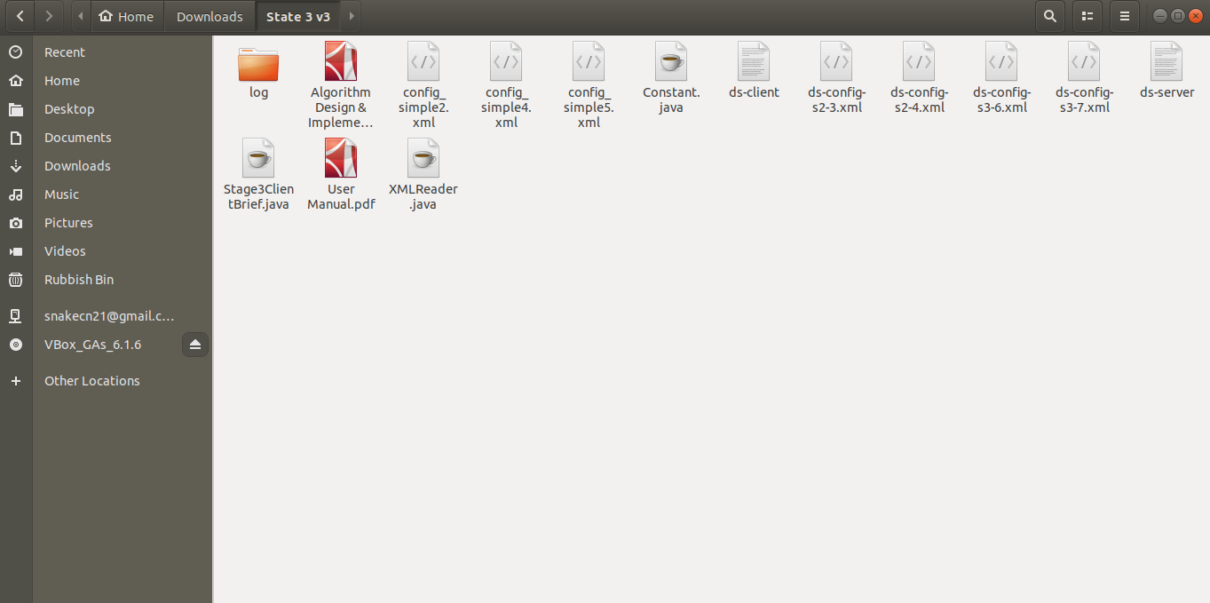

1. You will have two files ds-server and ds-client. To make them executable use the commands below:

# chmod +x ds-server

* 1. **chmod +x ds-client**

1. You have both server-side and client-side files ready. To run the simulator, open a terminal in the current path.
   1. Compile all java files **javac Constant.java javac XMLReader.java**

# javac Stage3ClientBrief.java

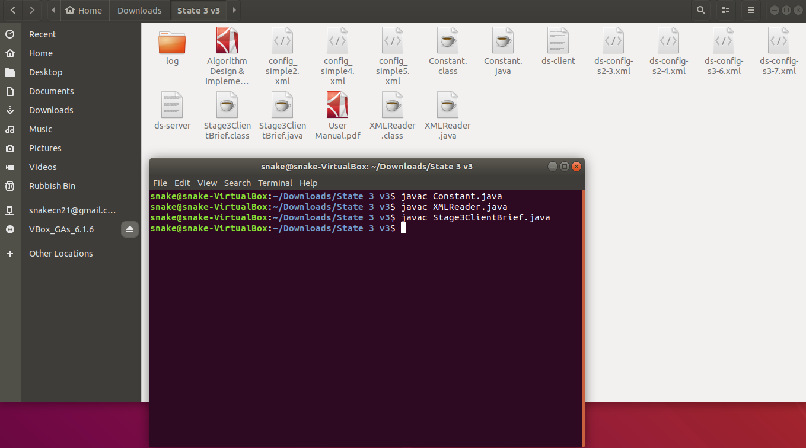

* 1. To run the simulator, you should open one more terminal and the result as shown below:

# In first terminal typing this: ./ds-server -c <config file name> -a brief

# In second terminal typing this: java Stage3ClientBrief

